**CRIME MANAGEMENT**

**COMP 122 -**

**Group project**

GROUP 4 ABDALLAH DIVKAR MOHAMMAD QUAZI AHMAD AL BOUCHI

ROJINA CHEMJONG

Initial Entity-Relationship Diagram

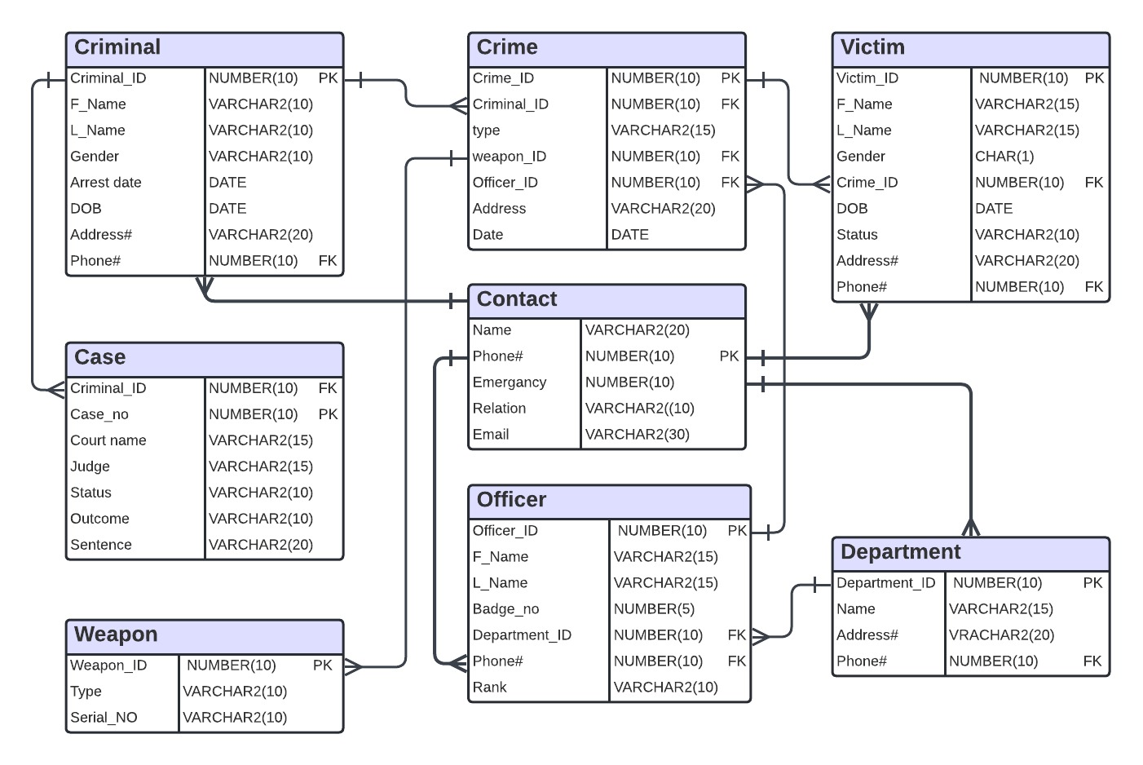

TABLE DESIGN

Table Name : Contact

|  |  |  |  |  |
| --- | --- | --- | --- | --- |
| Attribute | Description | Key Type / Constraint | Data Type | Field Length |
| NAME | Name of each individual |  | VARCHAR2 | 20 |
| PHONE# | Phone number of each individual | PRIMARY KEY | NUMBER | 10 |
| EMERGENCY | Emergency contact number if any |  | NUMBER | 10 |
| RELATION | Relation of the emergency contact to the individual |  | VARCHAR2 | 10 |
| EMAIL | Email of the individual |  | VARCHAR2 | 30 |

Table Name: Department

|  |  |  |  |  |
| --- | --- | --- | --- | --- |
| Attribute | Description | Key Type / Constraint | Data Type | Field Length |
| DEPARTMENT_ID | Unique number to identify each police department | PRIMARY KEY | NUMBER | 10 |
| NAME | Name of the police department | NOT NULL | VARCHAR2 | 25 |
| ADDRESS | Police department address |  | VARCHAR2 | 25 |
| PHONE# | Phone number of the police department | FOREIGN KEY | NUMBER | 10 |

Table Name : Crime

|  |  |  |  |  |
| --- | --- | --- | --- | --- |
| Attribute | Description | Key Type / Constraint | Data Type | Field Length |
| CRIME__ID | Unique number given to each crime when it is reported. The 1st 2 digits represent the type of crime | PRIMARY KEY | NUMBER | 10 |
| TYPE | The type of crime | NOT NULL | VARCHAR2 | 15 |
| CRIMINALS | Number of criminals involved |  | NUMBER | 10 |
| WEAPONS | Number of weapons involved |  | NUMBER | 10 |
| OFFICERS | Number of officers involved |  | NUMBER | 10 |
| ADDRESS | Address of the crime |  | VARCHAR2 | 25 |
| CRIME_DATE | Date the crime was committed |  | VARCHAR2 | 15 |

Table Name : Criminal

|  |  |  |  |  |
| --- | --- | --- | --- | --- |
| Attribute | Description | Key Type / Constraint | Data Type | Field Length |
| CRIME_ID | Unique number relating the criminals to the crime. | FOREIGN KEY | NUMBER | 10 |
| CRIMINAL_ID | Unique number given to each criminal. | PRIMARY KEY | NUMBER | 10 |
| F_NAME | First name of each criminal | NOT NULL | VARCHAR2 | 10 |
| L_NAME | Last name of each criminal | NOT NULL | VARCHAR2 | 10 |
| GENDER | Gender of each criminal (M/F) | CHECK | CHAR | 1 |
| ARREST_DATE | Date the criminal was arrested |  | DATE |  |
| BIRTH_DATE | Date of birth of the criminal |  | DATE |  |
| ADDRESS | Residential address of the criminal |  | VARCHAR2 | 25 |
| PHONE# | Phone number of the criminal | FOREIGN KEY | NUMBER | 10 |

Table Name : Case

|  |  |  |  |  |
| --- | --- | --- | --- | --- |
| Attribute | Description | Key Type / Constraint | Data Type | Field Length |
| CRIMINAL_ID | Unique number relating criminals to the case. Each criminal has a separate case. | FOREIGN KEY | NUMBER | 10 |
| CASE# | Unique identifier of each case. The last 4 digits are the same as the criminal id | PRIMARY KEY | NUMBER | 10 |
| COURT_NAME | Name of the court where the case is taking place |  | VARCHAR2 | 15 |
| JUDGE | Nmae of the judge for the case |  | VARCHAR2 | 15 |
| STATUS | What is the status of the case (Pending/Ongoing/Closed) |  | VARCHAR2 | 10 |
| VERDICT | Verdict of the case(guilty/not guilty) |  | VARCHAR2 | 10 |
| SENTENCE | The sentence given to criminal if found guilty |  | VARCHAR2 | 30 |

Table Name: Weapon

|  |  |  |  |  |
| --- | --- | --- | --- | --- |
| Attribute | Description | Key Type / Constraint | Data Type | Field Length |
| WEAPON_ID | Unique number given to each weapon | PRIMARY KEY | NUMBER | 10 |
| CRIME_ID | Unique number relating the weapon to the crime | FOREIGN KEY | NUMBER | 10 |
| TYPE | Type of weapon used | NOT NULL | VARCHAR2 | 10 |
| SERIAL# | Serial number of the weapon |  | VARCHAR2 | 10 |

Table Name : Officer

|  |  |  |  |  |
| --- | --- | --- | --- | --- |
| Attribute | Description | Key Type / Constraint | Data Type | Field Length |
| SERIAL# | Serial number of the records | PRIMARY KEY | NUMBER | 2 |
| F_NAME | First name of officers involved | NOT NULL | VARCHAR2 | 10 |
| L_NAME | Last name of officers involved | NOT NULL | VARCHAR2 | 10 |
| CRIME_ID | Unique number relating officers to the crime | FOREIGN KEY | NUMBER | 10 |
| BADGE# | Badge number of each officer |  | NUMBER | 10 |
| DEPARTMENT_ID | Department where the crime was reported | FOREIGN KEY | NUMBER | 10 |
| PHONE# | Phone number of the officer | FOREIGN KEY | NUMBER | 10 |
| RANK | Rank of officer | CHECK | VARCHAR2 | 10 |

Table Name: Victim

|  |  |  |  |  |
| --- | --- | --- | --- | --- |
| Attribute | Description | Key Type / Constraint | Data Type | Field Length |
| VICTIM_ID | Unique number given to each victim | PRIMARY KEY | NUMBER | 10 |
| F_NAME | First name of the victim | NOT NULL | VARCHAR2 | 10 |
| L_NAME | Last name of the victim | NOT NULL | VARCHAR2 | 10 |
| GENDER | Gender of the victim | CHECK | CHAR | 1 |
| CRIME_ID | Unique number relating victim to crime | FOREIGN KEY | NUMBER | 10 |
| BIRTH_DATE | Date of birth of victim |  | DATE |  |
| STATUS | Status of the victim(Dead/injured/unharmed) | CHECK | VARCHAR2 | 8 |
| ADDRESS | Residential address of victim |  | VARCHAR2 | 25 |
| PHONE# | Phone number of victim | FOREIGN KEY | NUMBER | 10 |

FINAL ENTITY-RELATIONSHIP DIAGRAM

